
Unity’s Vision
The endtime vision of a young girl from India named Unity.
(Part of the Shillong Revival)

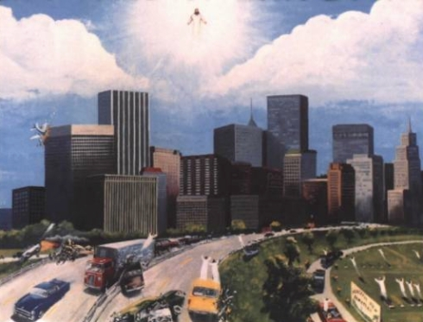
The day I had a vision of Jesus was on the Youth Sunday, March 9th, 2006.
Jesus told me of three things;
1. The Rapture of the Saints.
2. The Rule of the beast.
3. The Judgments of God.
All the Saints who have done His will were taken up into the Rapture, where Jesus appeared midway in the heavens. He took up all those on the Earth who did His will. The faithful ones who were in the graves were also taken up into the sky during the rapture.
After the rapture, I saw angels fight against a dragon who is the 666. He was defeated, and there was no room for him in heaven, so he fell to earth. The dragon said that he would rule over the earth for a number of years.
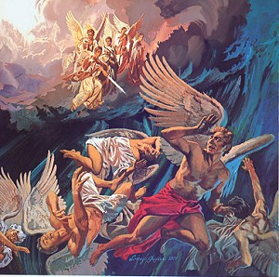
He went away and then another beast came which had 10 heads and 7 horns. He wore crowns on his head which had blasphemous names written on.
Announcer: Did he look him a human being?
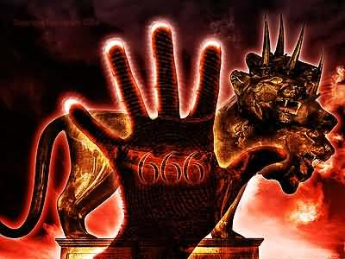
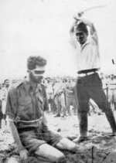
He looked like a human being, but very very fearful. I saw that during his reign, even the rice had his mark sealed on it. Even money had his mark sealed on it. People who believed in him had his mark sealed on them, which was 666.
Announcer: He put the seal of 666 on all commerce? So what happened to those who believed in Jesus?
Those who believed in Jesus, at that time, were severely persecuted. Their flesh was cut while they were alive, their eyes were gouged out. Their throats were slit and they were fried in huge containers.
When Jesus comes to earth again He ascended right down onto the surface of the Earth. When the dragon, who was the 666, saw the glory of Jesus, the dragon could not bear it and fled. When Jesus came down again, those who were dead, those who were left behind during the rapture awoke from their graves.
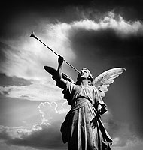
The Angels blew their trumpets and all the dead rose from their graves to go for the judgment day of God.
Announcer: Wonderful, wonderful, OK what else Unity?
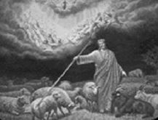
Then Jesus put the goats to the left and the sheep to the right. These goats were those who did not do His will and those who had the mark of the 666.
Those who were on the right were the lambs. They had the mark of the cross and they are the ones who did the will of Jesus.
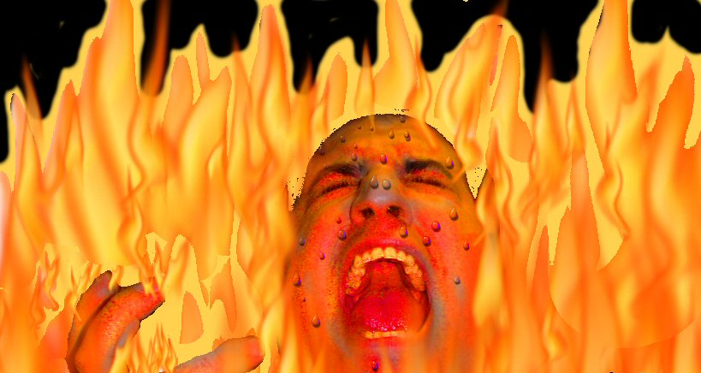
God then judged each and every person who Jesus divided into groups, the goats and the sheep. And each and every one was judged before God. And every person’s sins were viewed on a TV Screen.
God asked, “When a person witnessed to you about Jesus Christ, did you believe and repent or not?” If they replied “NO” then they were damned to Hell. I saw that those who were cast into hell, fell into a bottomless pit. They fell into the pit and where tossed about without reaching anywhere. There was a hot raging fire. They shouted and screamed begging Jesus for mercy.
I also saw a place full of worms, large snakes and hell fire. I saw people there too. The worms would go in through one nostril and out the other. I saw a big stringing caterpillar stuck to the cheek of one man. I saw a snake curl around the body and caterpillars crawling over peoples bodies.
REPENTANCE IS ONLY ON EARTH AND NOT IN THE AFTERLIFE
Announcer: What happened after that?
Jesus said that now is the time for you to repent. In this revival you will be saved. Jesus gave us this revival because He loves us.
Announcer: What else Unity?
That’s all. [End of this Vision] [Unity had another vision/dream on revival in Australia!]
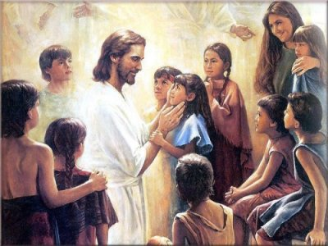
Announcer: Where in Australia, which city?
[Unity doesn’t seem to know which city she was carried off to in her vision /dream]
I met Jesus on a Sunday and He revealed to me some marvelous things. Jesus also took me to Australia, where I met 4 friends, John, Kenny, Mark and Mary. I saw many people looking joyful, dancing and singing. They had tasted the revival. I was singing and dancing and happy with them because Jesus had caused a revival in Australia. In that Australian church I saw many angels inside and outside the church. They were flying around in circles. They were blowing their trumpets and singing praises and thanks to Jesus. Then Jesus said He would take me to the same place and that we would meet again one day.
[End of Video]
http://www.youtube.com/watch?v=Fz5In54DLpY

