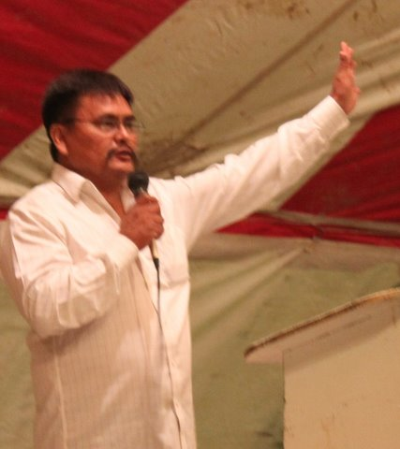
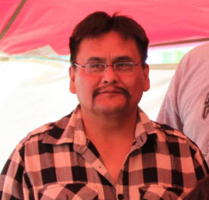
2nd Chances:
the Resurrection of Theo Nez

Hello dear brothers and sisters. My name is Theo Nez and I live in Farmington New Mexico. Today I like to share with you my testimony, about how God did a wonderful miraculous thing, for me and my family. He brought His precious salvation into our home.

In 1995, I was a wild person. I use to drink and take drugs, I didn’t care about nothing. One day, I overdosed on speed and my heart stopped. I died for four hours.

What I’m about to tell you, will make you think twice about life and death. When my heart stopped, the noise of the world faded away and total darkness came over me. I saw three demons come out of my heart, when they went out the window laughing.

As I left my body, I turned around and Jesus was standing behind me. His hair was golden white; He was wearing a white garment with golden sash. His shoes were golden sandals, and He walked and talked very gentle. There was light all around Him and my soul already knew Him.

I walked over to Him and asked; Jesus, where were you, I was looking for you. And He spoke very softly and said; I never left you, I’ve always been by your side. I was always waiting for you to repent and do the Father’s will.

You know, I was called to preach a few years back. I said, Lord I’ll go, but I run instead. I said, I can’t do it, I’m too young. When God calls and interferes with your life, you have NO other choice but to say yes to Him.

Then I told Jesus, I thought I would live for another thirty years. He said come, you have much to see. He took my hand and we started walking downward on a path. It was dark and Jesus Himself was the light. Soon I could see demons all around us. They were trying to grab for me, but I held on to Jesus hand as a little child.

He was my only protection and He started talking to me. He said, you know the Father is angry with you. It was because I was playing church and running like Jonah. The bible says Jonah was called to preach, but he run from God. I’ve done this for so many years. Now it’s caught up with me. I knew I died in my sins, and it was too late.

When we continued walking, Jesus spoke of many things and I asked many questions. We stopped at a certain area and Jesus said, look ahead. I could see some type of light in the distance. Jesus asked me; what do you think that is? I said, Lord that looks like hell, maybe the flames of hell.

Sure enough, as we walked closer, we come to the ledge of a canyon. The canyon was about two miles deep and about three miles across. Down below I could see flames, and everything was orange red. I started to tremble, I was afraid. I knew I was going to end up down there.

Jesus asked me to look down. I could not even look down, I started to cry and run behind Jesus. I started repenting, and I cried for the Lord to forgive me. I will preach now Lord, give me one more chance. I was crying like a baby.

We continued until we were down in the pit of hell. I saw many things that words cannot describe. The place was full of human souls, and demons were all around.

The bible says in Isaiah 5:14 Therefore hell hath enlarged herself, and opened her mouth without measure: and their glory, and their multitude, and their pomp, and he that rejoiceth, shall descend into it.

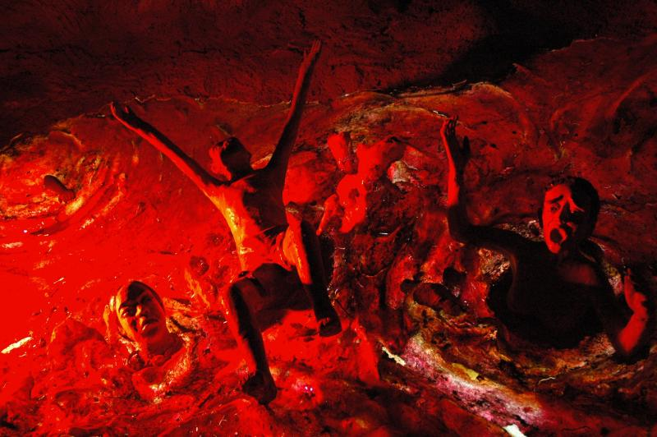
There were human souls tormented in the flames. Screams and cries were all over. There was no hope, no hope for the lost souls. Why? Because they rejected Jesus. Some waited too long. Many played church and ran from God. Running from God will get you into hell. Once in, you can never get out.

Please, I want you to lift up your hands and tell the Lord; don’t let this happen to me.

As we continue to walk, I was hundreds of thousands of pits. I was weeping and crying as we came to this certain pit that was empty. It had flames coming out of it. Jesus told me; this is the pit the devil has dug for you. There I started screaming. I cried, Lord, I don’t want to go there. I cried and repented, begging Jesus to give me one more chance. I cried like Jonah cried out of the belly of hell.

In the sixteenth chapter of Luke, we read about Lazarus and the rich man. The rich man had everything he wanted.
And there was a certain beggar named Lazarus, which was laid at his gate, full of sores,
²¹And desiring to be fed with the crumbs which fell from the rich man's table: moreover the dogs came and licked his sores. ²²And it came to pass, that the beggar died, and was carried by the angels into Abraham's bosom: the rich man also died, and was buried;
²³And in hell he lift up his eyes, being in torments, and seeth Abraham afar off, and Lazarus in his bosom. ²⁴And he cried and said, Father Abraham, have mercy on me, and send Lazarus, that he may dip the tip of his finger in water, and cool my tongue; for I am tormented in this flame. ²⁵But Abraham said, Son, remember that thou in thy lifetime receivedst thy good things, and likewise Lazarus evil things: but now he is comforted, and thou art tormented. ²⁶And beside all this, between us and you there is a great gulf fixed: so that they which would pass from hence to you cannot; neither can they pass to us, that would come from thence. ²⁷Then he said, I pray thee therefore, father, that thou wouldest send him to my father's house: ²⁸For I have five brethren; that he may testify unto them, lest they also come into this place of torment. ²⁹Abraham saith unto him, They have Moses and the prophets; let them hear them. ³⁰And he said, Nay, father Abraham: but if one went unto them from the dead, they will repent. ³¹And he said unto him, If they hear not Moses and the prophets, neither will they be persuaded, though one rose from the dead.

Oh people, please listen, this is reality, get right with God all you can. When we were back out, we were standing in an isolated area. Jesus said; listen. And I began to hear a women praying, I could hear her loud and clear, and as she prayed she said; Lord bring him back! Give him another chance. Lord he’s got two boys to raise. He is all I have. Don’t take him from me!

You believe prayer in faith can move anything? The bible says, what thing you desire when you pray, believe you have received them, and you shall have them.

And the women continue praying. Jesus asked me, what do you think that is? I said Lord that is my wife. I said Lord, did you hear that, I got two boys to rise. I began to touch Jesus on his shoulder, I can’t die now, my family needs me. I started coming up with many excuses, but there was no answer. I started to cry again.

My wife continues praying. There was a period of waiting what seams like hours and finally God the Father answer this, He spoke and His voice was like many waters. He said Son; I’m going to give you another chance because the prayer and the faith of your wife I will spare you. When I send you back, I’m going to use you.

There I started making many wows, I said Lord I’ll preach. I’ll do anything, I tell the people about this place, I said Lord, I will help you save souls.

Then we walked to a room with a giant screen like a television. I was shown my past, present and future. I could see my life, from a little child to an adult. Jesus gave me a revelation, a vision. He revealed many things that are about come to pass. He said, truly we are living in the last days. Go back and tell the people. Tell them to walk right and repent. Tell them they need to stop playing with Me and start keeping my commandments.

He showed me how people were hiding behind the bible, covering up their actions, and living in sin. God can hear and see all things. He said, these people honour Him with their lips, but their heart is fare from Me. Oh how they love to teach the commandments of men, but lay aside the commandments of God.

He said, fear not, I’m Alpha and Omega, the first and the last, what you are hearing is right. He said; he that has an ear, let him hear what the Spirit says to the church. He gave me three verses, warnings. First verse is in Deuteronomy 6:15.

(For the LORD thy God is a jealous God among you) lest the anger of the LORD thy God be kindled against thee, and destroy thee from off the face of the earth.

The second verse is in the book of Luke 16:13.
No servant can serve two masters: for either he will hate the one, and love the other; or else he will hold to the one, and despise the other. Ye cannot serve God and mammon.

Revelation 3:3, Remember therefore how thou hast received and heard, and hold fast, and repent. If therefore thou shalt not watch, I will come on thee as a thief, and thou shalt not know what hour I will come upon thee.

Brothers and sisters, we do not know when we are going to leave this world, we do not know what tomorrow holds, therefore I pray you get right with God while you can.



After this Jesus took me to Heaven and we walked through these golden gates onto streets of gold. I saw great a multitude of people of every nation and they stood before this throne, clothed in white robes. Some where people I knew, preachers and prophets from the bible. Everything so beautiful, everybody so happy; you could see the love upon their faces. I started to feel great joy and peace.


As I walk around, I didn’t want to leave. Jesus revealed to me a huge time clock. The hands are about to strike twelve, time is running out, time to go. I said Lord, I don’t want to go, I want to stay. But we had to leave.

As we were coming back, I saw the earth like a small golf ball. He brought me back to my bedroom where my body was laying. He reached out towards where my heart was. The flesh around my heart opened up. Jesus took my old heart out, and throw it in the lake of fire, then He gave me a new one, and the flash came back over it. I stood there watching and thinking, wow; even the skin and bone listens to Jesus.

Later on I searched my bible and found Ezekiel chapter 36 verses 26-27, I cried like a baby because it was scriptural, there the bible says:
A new heart also will I give you, and a new spirit will I put within you: and I will take away the stony heart out of your flesh, and I will give you an heart of flesh. And I will put my spirit within you, and cause you to walk in my statutes, and ye shall keep my judgments, and do [them].

After that Jesus put my soul back into my body, but my new heart was not running yet. I could see my wife still holding my hands praying.

Soon my bedroom was filled of thousands of angels, they was singing and praising with the most beautiful songs I’ve ever heard. The music itself was so overwhelming. One angel stuck out and spoke, he said; the Blood of Jesus is coming. And all the angels began to praise and worship.

Then the Blood of Jesus came upon us, and from my head to my toes it washed all the sins away. The alcohol and drugs went out of my body. It felt like warm water. As I looked at my self, all the darkness of my body was gone. I was all white and clean.

Moments later the same angel stepped out again and said; the Holy Spirit is coming. The angels began to sing and worship again. The Holy Spirit came upon us and filled us. My soul was jumping up and down. At last I got the Holy Spirit. The Spirit of the Lord was hot like electricity; He was like fire burning in my bones.

The angels were still singing and praising when Jesus said; son, go tell the people what I reveal unto you. He touched my new heart with his finger and it started to work. Then slowly my eyes began to open. I realized my body had gone cold, I could barely speak. I asked my wife what happened. She looked at me and said; are you alright? Then she began to cry.

There was still pain all around my chest area, it felt like I had surgery. I was so weak and thirsty; the first thing I asked for was water. Soon my memory started coming back and I remembered what had happened. There I fell on my knees and prayed for the next three hours till the sun came up.

From that day on, my life has been different. I was a rebel, but God brought me down on my knees, crying like a baby, begging for mercy. I use to think, I’m going to hell, it doesn’t matter. But I never would I realize how painful hell would be until the Lord revealed it to me. Now I thank the Lord every day for the life he has restored unto me, my family, and the ministry he gave me.

Brothers and sisters, I pray that you are not playing church and serving two masters, because you can NOT play with God. It’s a very dangerous thing to fall into the hand of the living God. So don’t be deceived, God is not mocked. The bible says; what a man sows, he shall reap, he who sows wickedness, he reap the same.

Yes God is a God of love; he is full of compassion and mercy. He is a God of second chances, but He is also a God of judgment. The bible says Be is a consuming fire. So you need to prepare, because you do not know when you are going to die. The bible says in Hebrews 9:27, And as it is appointed unto men once to die, but after this the judgment:

The day is coming when we all will stand before God, and our books will be opened. You are going to be there. Everybody that listens to this testimony will be there. That is one appointment you will never miss. This maybe is your last call, don’t rebel against God. Think about it, it’s going to be either heaven or hell. You may not get another chance like I did; it was only by the grace of God.

I’m here today to share with you my testimony, I want you lift up your hands and speak to the Lord, thank Him for warning you, thank Him for this precious life. If you want to be saved, you need prayer, let me pray with you right now:

Lord Jesus, forgive me. I receive you as my personal Saviour. Come into my heart and life. Give me eternal life, so I will live with You forever. Give me a life of peace and joy. Thank You Lord. In Jesus Name, Amen.

If you want to write to me my address is:

Last living days Ministries
P.O. Box 3701
Farmington, NM 87499
USA

What you heard in this testimony is a true story. I’m a Navajo Indian. I live in the Four Corners. I dedicate this tape to all the Native Americans across America. I give my permission to duplicate this testimony.

