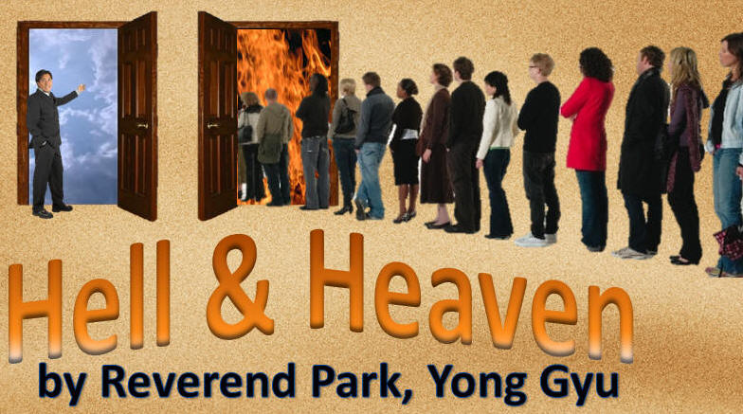
Heaven and Hell:
By Rev. Park, Yong Gyu.
http://www.DivineRevelations.info/PARK

In 1987, Reverend Park had died from high blood pressure. But by the grace of God, his life was extended for another 20 years. However, for the first four years, he was not able to speak due to his condition. He was about 50 years old when he had come back to life. During his death, the Lord showed him to Heaven and Hell.

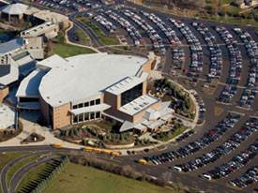
I want you to know if you are arrogant and prideful, you will bring curses upon yourself. I had a mega church of 5000 members but I was struck down by God due to my arrogance. Now I fear God. (James 4:6)

I used to own property worth about 150 million US dollars. I owned five luxury cars. But after my death experience, I gave it all away. Please remember, salvation cannot be achieved by your possessions but through faith. And now I plead to the deacons, elders, and the other leaders in their churches to serve your pastors with all your heart.

On December 19, 1987, after I had finished my lunch and while I was resting, I began to feel excruciating pain, it was so unbearable that I felt as though I was going to die. Then I lost consciousness. I woke up four months later in a vegetated state, and my doctor told me that I would eventually die. All my body parts were mangled very badly from the paralysis. And my family had never allowed any of the church members to visit due to my horrible appearance. Then I finally died.


When I died, I saw two people enter my room. But these people had entered into my room through the wall. I screamed, “Who, who are you!! My house will crumble down if you do that!!” Then one said, “We are angels descended from Heaven. We are from God’s kingdom.” A brilliant light shinned from the angels.

The angel to my right introduced himself. “I run errand for Jesus in His kingdom. Jesus called me and commanded me to go down to the Earth. He commanded me to take you to Heaven. You are dead. But since your family cries out with so much sadness, He desires to grant you a little more time to live. But for now, He desires to show you Heaven and Hell. He will show you and you will witness to the people of the Earth. May the number of people who end up in Hell be decreased and the number of people going to Heaven increased through your testimony. This will be your mission. God instructed us to tell you not to delay. If you delay, you will not be able to visit Heaven and Hell.”

Then the angel to my left said, “The moment you were born and until the moment you had died, I had been with you.” At that time, I did not understand what the angel had meant. Now I know. He was my guardian angel. So I said, “I cannot go! I will not go! I am a pastor! I cannot meet the Lord in this physical condition. I want to see Him as a healthy person. I would probably be receiving more rebukes than compliments from the Lord. I am prideful and arrogant and now I am cursed and sick. How am I able to enter Heaven? I am so scared. Please go back to Heaven and ask the Lord to heal me. Then come back and take me to Heaven through my dream. Please ask for mercy on my behalf.”

But the angels were not listening to my arguments. They took my clothes off and said that they were too filthy to be wearing in Heaven. They then clothed me in a white gown. (Zech 3:4)


They grabbed my hands and we flew straight up to Heaven. We flew through the clouds and as I looked down, I saw the Earth becoming smaller. They let me go near an endless Golden Street. I saw a brilliant shining light, too bright to look directly at. I said, “Where is the light coming from?” “It is from Heaven” the angel responded.

I thought, “Wow! It is huge!” I saw groups of people in white gowns flying ahead. “Who are they?” I asked.

The angel replied, “They are the ones who had served God faithfully and trusted in Jesus by obeying and following the lead of the Holy Spirit with all their heart. Their bodies are dead on Earth. They are now the souls heading toward Heaven.”

The other angel continued, “There are twelve gates in Heaven. When a saved soul comes to Heaven, they must enter through one of those gates.” We were standing in the south gate but it was closed. As we were waiting, I asked the angel, “Angels, why is this gate not opening?”

The angel replied, “It is because you are not singing the Heavenly worship song.” (Psalms 100:4)

I asked, “Angels, I was very prideful and arrogant and as a result I was cursed with sickness. I am not good at singing Earthly worship songs. How am I able to sing Heavenly worship songs when I had never heard it before?”

The angel replied, “You are correct. But you must still prepare yourself to worship. You are a prideful person but prepare to sing.” The angels began to sing. As they sang, I began to sing with them. It became natural to me, and we entered in.

The scene of Heaven was indescribable. I can’t describe Heaven with my Earthly words. I said, “Lord! Thank you so much! Even though, I was very prideful and arrogant and cursed with a sickness, You have still brought me to Heaven to show me around.”

I then heard the voice of God, “My beloved Pastor Park, Yong Gyu, I welcome you. You have made a long journey here.” His voice was overflowing with love and tenderness.

I replied back crying in tears, “Lord,….” The angels immediately said, “you have been a pastor for 20 years. Do you not know your scriptures? There are no tears in Heaven. Please stop it!” I was not even able to cry. (Rev. 21:4)
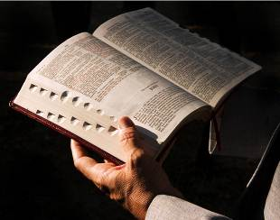
The Lord then asked me five questions.
“How much time did you spend reading the Word (bible)?
How much did you give of offerings?
How many times have you evangelized to people?
Did you tithe properly?
How much time did you spend in prayer?”

I could not answer the fifth question. The Lord rebuked me for the fifth question.

“After you had become a mega church pastor, you had become very lazy with prayer. Being busy is no excuse to Me!” I had to repent of it later. “The angels will show you many places in Heaven and of Hell. Look around as much as you desire. You will leave after witnessing many different places in Heaven and Hell.” But the Lord did not allow me to see His appearance.

The angels first took me to three different places in Heaven.
In the first place, I saw little children living together.
The second place was where the adults lived.

The third place was where the souls had barely made it to Heaven. Even though they made it to Heaven, they had made it shamefully.

Many people had asked me how old the little children were. They appeared like kindergartens. They were not the little boys or girls as we would know of gender. Each child had their own baby angel to accompany them.

In Heaven, most of the souls will have their own individual home. (John 14:2) However, there were some who did not have homes. I will explain this later. Moreover, the children did not have their own individual homes either. I asked, “The children are also souls, why do they not have their own homes?”

The angel replied, “Just as the people on Earth require materials to build their homes, we in Heaven also need materials to build here. When a person serves the church and others faithfully unto the Lord, those deeds will become materials for a person’s home in Heaven.
When the materials are provided, the angels assigned to build a saint’s home will go to work on constructing it. The children who are below the accountability age have not built up any materials to build a home. In other words, they did not have the time or chance to earn their rewards/materials. This is why they do not have homes.”

I continued with my questions, “What shall I do on Earth to provide more materials for my home?”

The angels replied, “There are seven things one must do to build up their materials to build their home.

The first is their accumulation of worship and praise to God.
The second is their time spent reading the bible.
Third, their time spent praying.
Fourth, their time spent evangelizing to people.
Fifth, one’s offering to the Lord.
Sixth, their obedient tithes to God.
Lastly, their time spent serving the church in any way.
These are the deeds or works of obedience in which one accumulates materials for their Heavenly home. If one is lacking in these areas, they will have no materials to build their home.”

There were numerous people in Heaven without homes. Many who did not have homes were actually pastors, deacons, deaconesses, elders, etc. I asked out of curiosity, “Where do the children live then?”

The angels replied, “They live here.” As I looked around, they were gathered throughout the garden of flowers. The garden of flowers was so beautiful and the fragrance was out of this world. The scene was beyond what I could describe with my words.

The second place was for faithful adults. There is a difference between salvation and rewards. This place had so many homes. The homes were built with beautiful gems and rare stones. Some of the homes were as high as the highest skyscrapers on Earth. Those people who had faithfully served the Lord while living on Earth had their homes built with beautiful gems and rare stones. In this particular place, all the people looked around the age of 20 to 30 years old. There were no men or women in regards to gender. There are no sick, old, or lame people.


I once knew an elder named, Oh, Im Myung. He had died at the age of 65 years old. He was a very short man, as tall as 2nd graders in elementary school. He had suffered from a rare disease called rickets. However, when it came to the bible, he was a PHD. He had written many commentaries. I met him in Heaven, and there he was tall and handsome. He was no longer sick but healthy. Heaven is a very wonderful place!! I am so full of expectations! Please believe what I am saying beloved people!

The third place was for those who were shamefully saved. (1 Cor. 3:15) This particular village was enormous in size, several times bigger than the second place, where the homes were made of gems and rare stones. I arrived at this place at great speed, riding a golden chariot. It was very far from the other beautiful places I saw in Heaven.

I asked the angels, “I see great wilderness and fields. Why do I not see homes?” The angel replied, “What you are seeing are homes.”


I saw huge wide flat houses, which reminded me of a large chicken coop or some type of warehouse. These homes were not glorious, but shabby. This village and homes were for the souls who were shamefully saved. There were numerous large sized shabby looking homes. This village is several times bigger than the place where rewarded souls reside.

The angel said, “Do you see the two large homes, one to your right and one to your left? I answered, “Yes, I do see them.”

The angel said that he wanted to show me those two houses specifically. He said, “The right home is for those who were pastors on the Earth. The left home is for those who were elders on the Earth.” As we arrived to the front of the two homes, I noticed they were humongous. My jaw dropped. When we opened the door and entered, my first impression was, ‘chicken coop.’ Instead of thousands of chickens living in their coop, I saw souls. The angels advised me to observe very carefully because I would recognize some famous pastors from history. It was true. I recognized many pastors from history. I specifically picked out one pastor and asked the angel, “I know that Korean pastor! I know how famous he was and the work he had done for the Lord. Why is he here? I do not understand.”

The angels answered, “He never provided any building materials for his home. This is why he is living in a community home.”
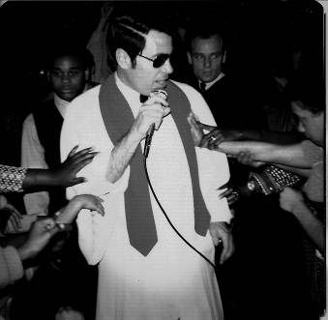
I asked out of curiosity, “How did this happen? Why did he not have any materials?” The angel answered, “While he was a pastor performing the functions as a pastor, he had loved to be complimented by the people. He had loved to be honored. He had loved to be served. There was no sacrifice and servitude on his part.” This particular pastor was greatly honored in Korea and is an icon within the Korean Christian history. But he had no reward!!

You pastor out there, please listen! You have to lead people to more than just Sunday morning services. You must visit them in their homes. You must take care of the poor, the lame and old. The pastors who have served without sacrificing their lives and loved to be honored have no reward in Heaven. (Matt 23:5-12)

After I had witnessed this scene in Heaven and after I had come back to the Earth, I immediately gave all of my possessions away including my five luxury vehicles. Our life is but a moment. In the bible, the average life is about 70 to 80 years old. But it is only God who knows when a person will die. Anyone can die before the age of 70 or 80 years old. I had decided to give everything away, even my clothes. The people I saw had received salvation in shame. They were pastors, elders, deacons, and lay believers. There were multitudes of elders and deacons in this flat shabby home. But of course, it is much better than Hell. However, why would anyone want to enter Heaven in such a way? I will not end up in that shameful place. Their clothes were even shabby.


What are the requirements for Christians to receive such beautiful homes in Heaven? First, we have to evangelize to as many people as possible. How should we evangelize? The angel told me, “Assume there is an unbeliever who does not know the Lord. The moment you decide to evangelize to that particular person, the building materials for your homes will be provided. As you unceasingly pray for their salvation, more building materials are provided. You must continue to check up on them, visiting them and continue your evangelizing. This will add more materials to your home. If a person says he/she cannot make it to church because they do not have nice clothes, then you must provide them with some. If the person says he/she does not have a bible, you must provide one. If a person says he/she does not have glasses to read, you must provide it for them. You must provide whatever you are able too so this person can be led to the Lord. Those who live in the best homes are those who had evangelized many times.”

The angel then escorted me to the place where the saints lived in nice homes. This is where saints who had evangelized much lived. It felt like downtown Heaven.

In Christian history, there are four people who have the biggest and most beautiful homes. The angel showed me the home of American evangelist D.L. Moody, British Pastor John Wesley, an Italian evangelist, and Korean Evangelist Pastor Choi, Gun Nung. These four people have the largest homes in Heaven. These four had spent their whole lives evangelizing to people even through up to the time of their deaths.


Within the Korean believers, there was a lay believer who had a large home. This lay believer had built many church buildings with his all his possessions. He had given three thousand bags of rice to the poor. He secretly helped thousands of pastors and leaders with their finance. He helped students studying theology or in bible school with their tuitions. He had also taken in a pastor (65 years old) into his home and took good care of him. His own church had kicked him out.

I heard an angel shout, “The materials are coming!” I questioned the angel to my right about the materials and he told me, “These materials are for a deaconess from a small church who is from the country. In fact, she receives materials every day. Even though she is poor, she comes to early morning service each day. She prays for 87 church members daily. When she finishes praying, she cleans up the church.”

I heard another angel shout, “Special delivery! The daughter of the deaconess has given what little money she had to her mother. However, the deaconess did not spend it on herself. She bought five eggs and two pairs of socks for the church pastor. Even though it may appear to be a small offering, she had given all she had for the day. This became special materials for her home in Heaven.”

Second, those who also have a large home are those who have built church buildings or other buildings for Kingdom purpose with their possessions and resources.

In Heaven, I also met an elder named Choi. Among all the Korean elders and deacons who are in Heaven, he had the most beautiful home. His home was much higher than the tallest building in Korea. Choi had built many churches in Korea with his wealth.

I asked the angel, “How about my house? Is it in the process of being built? The angel said, “Yes it is.” I begged to see my house. But they told me it was not allowed. I continued to beg and after some persistent begging, the angels said that the Lord will now allow it.

We entered the chariot and traveled very far to another place. I was full of expectation. I asked, “Where is my house?” The angel replied, “It is over there!” But it looked as though the place was only a foundation, only ready for development. I cried out, “How could you do this to me? How could this be happening? How can my house be in a developing zone? Surviving the Korean War, I sold my only home to build a church. This church eventually grew to five thousand members. I wrote many books inspired by the Holy Spirit. One book became a best seller. With the proceeds from the books, I built Christian schools. The school birthed 240 pastors. During tenure as the dean, I had given out over 400 scholarships to over 400 poor children. I have built homes for the widows to live in. This all cost huge amounts of money. So how could this be? Why is my home in a land development? I am so upset!”

The angel replied sternly, “You do not deserve to live in such a beautiful nice home in Heaven because you have been honored by people countless times. Every time you had built or done something good, you were praised by people. You were even honored by the secular news. Therefore, all your works are in vain.” (Matt 6:1)


I looked at my home in the development zone. It was located in the middle of three other homes. It only had three stories. The house had many small rooms on the first two floors. I asked the angel, “Why do I have such small rooms?” The angel answered, “These rooms are for your sons and daughters.”

“I only have four children,” I replied. The angel responded, “No, they are not for your Earthy children, but for the ones you had evangelized and are saved.” I loved it! I asked, “Where is my master bedroom?” The angel said that it was on the roof. That bothered me. My room was not even finished. In an angry tone I said, “It is so small! Why is it so difficult to finish?” The angel replied, “You are not even dead. We cannot finish your home or rooms because we do not know if more materials will be provided. Do you understand?”
When we entered my room, I saw two certificates hanging on my wall, so I went to read them. The first certificate described when I was 18 years old living in an orphanage. On Christmas day, I was on my way back to the early morning church service. I had seen an elderly man shivering on the street. I took my jacket off and gave it to him. That deed had given me a reward in Heaven. The second certificate described the same incident but it was for buying some bread with the little money I had for the elderly man. The amount is not the issue. The act must be accompanied by genuine faith. The dollar amount has no significance.


We left the place and headed back out. During the ride, one of the angels asked, “Are you sad? I will tell you how to have a beautiful home built. The Lord said when you go back to the Earth, you must go to tell the people about Heaven and Hell as you have witnessed. Second, the Lord desires you to build a place to gather elderly female pastors and evangelists who do not have places to go or live. If you truly faithfully do these things, you will have a beautiful home.”
Hell

The two angels escorted me to Hell. They said, “Now you will visit Hell.” You have no idea the enormity of Hell. I kept shouting, “It is so big! It is so big!” This is the place where souls who are cursed and receive eternal damnation are placed. It felt like Hell was a thousand times larger than the Earth. Half of Hell was colored red and the other half was pitch dark black. I asked the angels, “Why is this part red?”

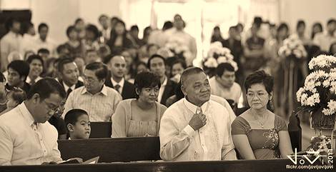
The angels replied, “Do you not know? It is burning sulfur. The other half is darkness. When people sin and end up here, they will be tormented from both sides…There are multitudes of churches on the Earth and many of the churches are filled with many people. However, most of them are not true Christians. They are but church attendants. The true churches will firmly believe in Heaven and a Hell. The lives of many Christians are in chaos because they do not firmly believe in Heaven and Hell. When one soul enters Heaven, one thousand cursed souls enter Hell. The rate of Heaven and Hell is 1 to 1000.” (Matt 7:14)

I am a Presbyterian pastor and a well-known speaker. I have graduated from one of the largest theological school in Korea. I never believed those Heaven and Hell stories. But now, I am one who writes such experiences to testify to others. Although you may believe you are a Christian, if you live your life according to the will of demons, you will end up in Hell!

The first place I saw was a place of burning sulfur. You can’t even imagine how hot the fires of Hell are. No one can bear the intense heat.

People in Hell say three statements.
First, it is too hot and they feel like dying. (Luke 16:24)
Second, they are so thirsty and feel like dying.
Third, you will hear many asking for water. (Zech 9:11)

It is eternal! Many people say we are free in Christ and they live their lives as they desire. I asked the angel, “Those who are in here, what have they done?” The angel answered, “The first group is unbelievers.” Those who had not evangelized to their own family must repent!

The angel continued, “The second group is those who believed in Jesus, but did not repent of their sins.” We must repent of our sins and must confess to the Lord. We must not sin. Just giving lip service is not repenting. With a contrite and earnest heart, we must repent!
Christians in Hell

I then saw many pastors, elders, and deacons in Hell. I asked the angel, “I know them. They had served God faithfully while on the Earth. They had died some time ago. We all had thought they were in Heaven with God. But now, I see them all in Hell and they are crying out that it is so hot! Why are they here?” There were so many pastors, elders, deacons and all other lay believers.

The angel answered, “Pastor Park Yong Gyu, a person can appear to be a true follower of Christ on the outside but God knows the heart.

THEY DID NOT KEEP SUNDAYS HOLY. IN FACT, THEY HAD LOVED TO MAKE MONEY ON SUNDAYS. (Jer. 17:27)
Many of the deacons and elders had criticized the sermon of their pastors.

(PS. 105:15) (Num 12:8-9)
THEY DID NOT TITHE PROPERLY. (Malachi 3:9)
THEY DID NOT PRAY.
They had not evangelized to people at all. (Ezekiel 33:6)
Many of these elders and deacons had harassed their pastors and would come against their authority. They had interfered with the pastor’s duty and business. (Num. 16)
On their death beds, they thought they had done a good job so they did not repent of those things. This is why they were thrown in the fires of Hell.”

I then saw a king and a prince who were had first persecuted Christians in Korea. This king and prince beheaded many of the first believers in Korea. They were placed in the center, which was the hottest place of all. I also saw Hitler, Stalin, Mao Zedong, and a famous pastor from North Korea named Pastor Kang, and a famous Japanese hero, and many more.

Then we arrived at an extremely dark place, too dart to see where to step. I shouted, “Angels! Angels! It is so dark! How can I see anything?” The angels patted my shoulder and said, “Just wait a little bit.”

Within a few moments, I was able to see a countless number of naked people. All of them had insects crawling all over their bodies. Not an inch was spared as their whole bodies were completely covered with insects. The naked people attempted to drive the insects away gnashing their teeth. I asked, “What did these people do as they lived on Earth?”

“They are those who have criticized and back stabbed each other. They were not careful of what they had said to one another.” (Matt 5:22)

I saw the demons piercing and stabbing the stomachs of the people with sickles. Their screams were unbearable to me. I asked my escort, “Angels, what did these people do as they had lived on the Earth?

“These people had jobs, houses, and families but they did not give to God. They did not help the poor, their churches, or other Godly purposes. They were very stingy and greedy. Even as they encountered the poor, they ignored them and did not care. They only cared for themselves and their families. They were well clothed, fed, and had a comfortable life. This is why their stomachs are pierced for their bellies were full of greed.” (Proverbs 28:27)

It was a very frightening scene. After witnessing such a scene, when I got back to the Earth, I gave all of my money and possessions to others. Salvation cannot be earned with money or property. It is by faith. Hell is an unbearable and miserable place. It is eternal torment!

I also saw people who had their heads hacked off by a very sharp saw. I asked the angel, “What did these people do to deserve such awful torment?” The angel replied, “Their brains were given by God to think good and beneficial things. But these people had thought of filthy things. They thought of lustful things.” (Matt 5:28)

Next I saw people being stabbed and cut into pieces. The sight was horrible. I asked, “What about these people? What did they do to be tormented in such a way?” The Angel replied, “These were elders and deacons who did not serve their churches. In fact, they did not even want to work or serve! The only things they had loved were to receive and receive from the flock.” (Zech 11:17) (Hosea 6:5)

I saw the elders, deacons, and other lay believers tormented by the demons. The demons made a hole in their tongues and placed wires through the tongues of one another. Then the demons dragged the people with the wire. I asked again, “What did they do on Earth?” The angel answered, “They had committed four different types of sin.
First, they had criticized their pastors. They would speak negative things about their pastors. They were back biting and ridiculing their pastors.”
(James 3:6) (Matt 12:37)

I plead with those who have committed such acts to REPENT, REPENT!!

The angel continued, “Second, they insulted the church with their words. They had harassed other Christians to the point where even the faithful ones were affected and they stopped attending church and even caused some to stop believing. They did all they could to stop faithful Christians from doing God’s work. These wicked ones caused many faithful to stumble. Lastly, there are spouses who drank alcohol and were abusive to their family members.”


I saw demons piercing men and women in their stomachs with a very huge sharp nail. I asked, “What did they do?” The Angel replied, “These are men and women who had lived with one another but were not married. These are guilty of abortions as they also got pregnant. They had never repented.”

I saw another group of people. The demons were slicing their lips as if one thinly slicing meat or vegetables. I asked, “Why are these people tormented in such a way?” The angel said, “These are sons, daughters, son in laws, and daughter in laws who had talked back to their parents. All they had to do was say, ‘I’m sorry’ instead of making things worse. Many of them had used abusive language. They had attacked their parents with harsh language. They were rebellious. This is why their lips are being sliced.”

Brethren, we are all going to die one day, but we don’t know when that will be. Please be prepared. Being prepared is to go to Heaven. When we go is not the issue. Please forgive each other as frequently as necessary if you need too. Repent and repent and do it all day long if you have too.

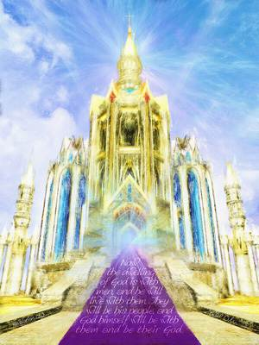
My beloved brethren, I used to ignore such testimonies. I was a conservative Presbyterian pastor who ignored such things. But now, I must witness and testify to you what I have seen. Please do not hesitate to live a holy life. Please avoid this miserable torment and judgment. Be saved! Do not live for your flesh but submit to the Kingdom of God. Please pray for those who do not know Jesus. Evangelize and bear fruit. Please pray early in the morning and keep Sundays HOLY. Please tithe to the Lord properly. Accumulate your rewards in Heaven and not in this Earth. I pray and bless you in the Almighty Name of JESUS!

By Pastor Park, Yong Gyu

Editors Note: Please remember the Lord never said that your chances of getting saved was 1 in 1000. We need to beware of the deception that it is nearly impossible to be saved, so why even try. Salvation is not something that you earn. When the prophet Bob Jones saw the 2 lines in 1975, he estimated that about 1 in 50 were being saved at that specific time.

