“Advanced Tactics of Spiritual Warfare” Transcript
------------------------------ Slide #1 --------------------------------------------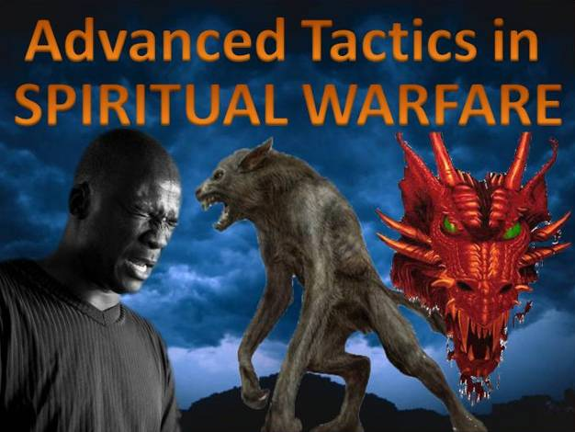

------------------------------ Slide #2 --------------------------------------------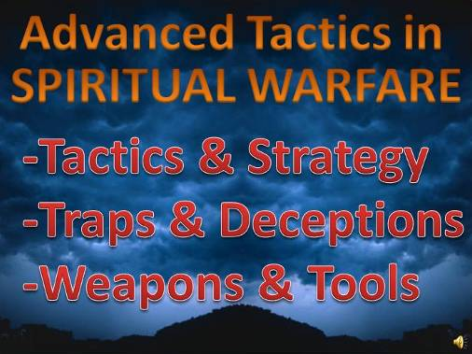

------------------------------ Slide #3 --------------------------------------------
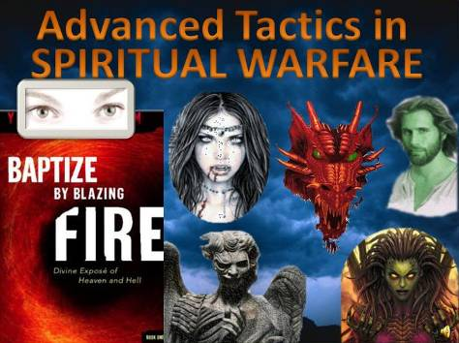
This video will go over some of the Advanced Tactics of Spiritual Warfare, which were revealed through the book “Baptized by Blazing Fire.”

This 5 book series was an account of a 30 days continual midnight prayer rally at a small Korean Church. During their midnight prayer, Jesus granted some of the members the gift of OPEN SITE, so that they could actually see the spiritual battles taking place while they were praying.
Many of us, who are familiar with Spiritual Warfare, know these battles are happening, but we could never see them. Now we have a valuable firsthand account of what is actually taking place during Spiritual Warfare.

Through intense spiritual fighting they were shown how devils, demons and unclean spirits try to distract us, scare us, and deceive us while we are praying. Every demonic trick in the book was used against them to hinder their prayer.

They encountered and fought against numerous
vampires, dragons, false christs, false angels, and many other demonic spirits.

They were shown satan's strategies used against Christians, and shown powerful new spiritual weapons useful in defeating the enemy.

------------------------------ Slide #4 --------------------------------------------
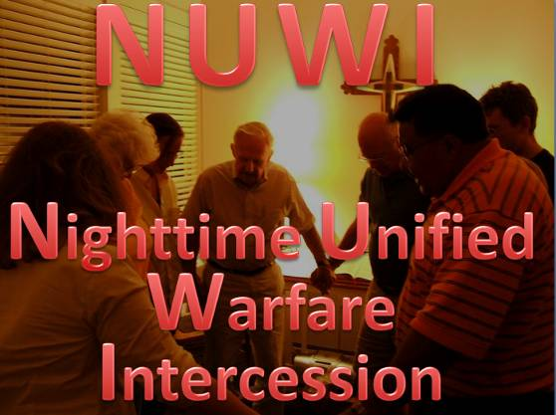
This will also document a unique and powerful form of Warfare called NUWI. Nighttime Unified Warfare Intercession.


------------------------------ Slide #5 --------------------------------------------
First of all, what are we up against?
This is a warning to anyone who engages in this type of warfare, you are up against the demonic realm, satan’s kingdom,
--- more powerful than any government,
--- more sophisticated than any international business,
--- and more influential than any world organization.

------------------------------ Slide #6 --------------------------------------------
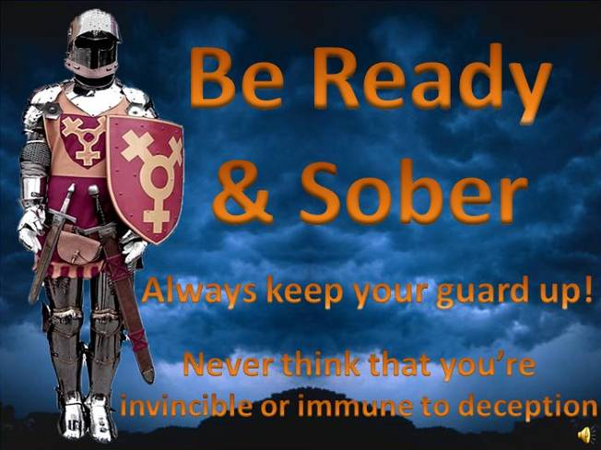
When engaging in spiritual warfare, if you’re not clearly prepared, the demonic realm can ruin your life or the lives of those around you, they can ruin your marriage, your Job, your property and even get you killed.

So it’s wise to have sober judgment regarding the demonic realm.

It’s wise to have great faith in God, and NO confidence in the flesh.

Always keep your guard up, and never think you’re invincible or immune to deception.

------------------------------ Slide #7 --------------------------------------------
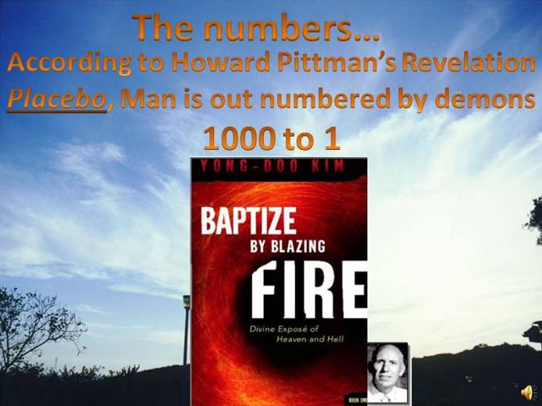
The Numbers.

In Howard Pitman’s revelation, “PLACEBO” he was shown the demonic realm, also known as the 2nd heaven, by an angel of the Lord.

He estimated that we are outnumbered 1000 to 1, by demonic spirits, of all shapes sizes and appearances.

Also, from the book Baptized by Blazing fire, when a Christian with the gift of Spiritual site looked up into the sky during day time, he saw that the whole sky was covered end to end in evil spirits, there wasn’t even one spot where light was coming through.

------------------------------ Slide #8 --------------------------------------------
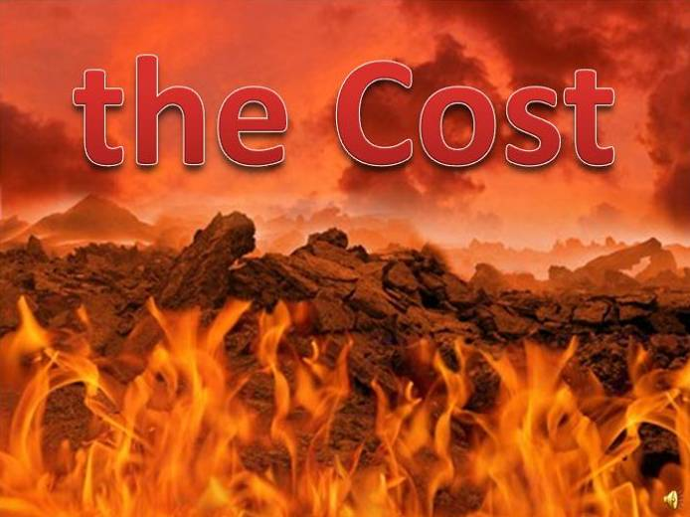
The Cost

------------------------------ Slide #9 --------------------------------------------
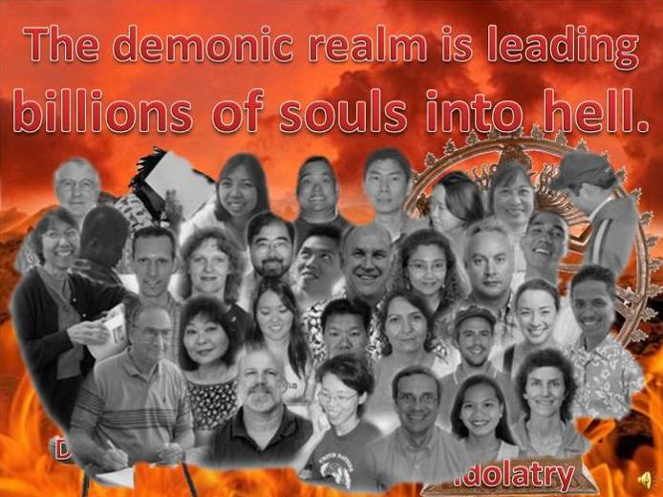
The demonic realm is leading billions of souls into hell, an eternity of unspeakable suffering and torment.
They use a multitude of ways & methods to trap people in sin.

Depression
Idolatry

------------------------------ Slide #10 --------------------------------------------
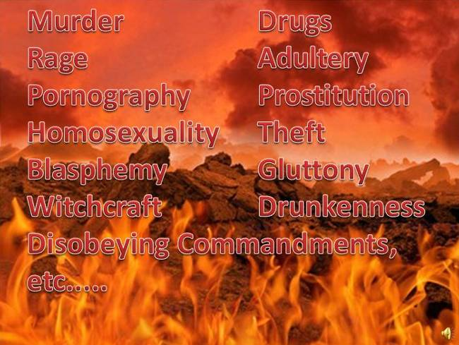
Murder Drugs
Rage Adultery
Pornography Prostitution
Homosexuality Theft
Blasphemy Gluttony
Witchcraft Drunkenness
Disobeying Commandments,
And many others
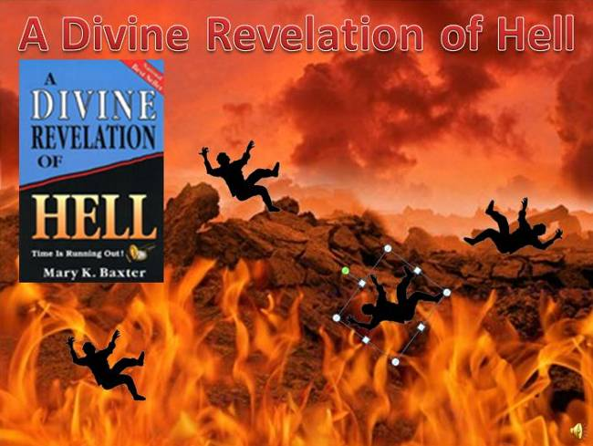
------------------------------ Slide #11 --------------------------------------------
In the book, “A Divine Revelation of Hell”, when Mary K. Baxter was shown hell, she saw the souls of people who had recently died on Earth. They were falling into hell.

This process would continue day and night, as people died, their souls would fall down to the entrance of hell.
As soon as a soul fell in, a group of demons would chain it up, and drag it away to be tortured. The souls would frantically scream and fight, to escape, but it was no use.
The Majority of the world's people ended up here.
Most, did not even believe that hell existed.

------------------------------ Slide #12 --------------------------------------------
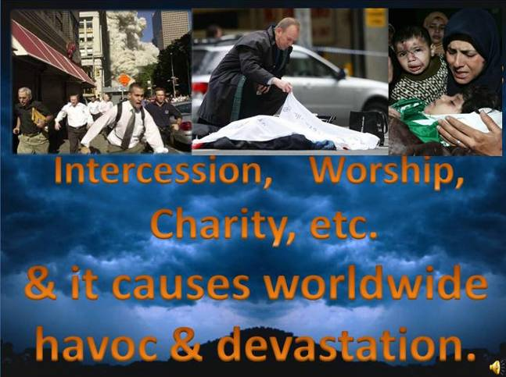
The demonic real hinders every aspect of the Church; Evangelism, missions, intercession, Worship, charity, etc.

And it causes worldwide havoc and devastation. Destroying lives, marriages, friendships & property.

Therefore, any advancement against the demonic realm will benefit EVERY aspect of the Church.
------------------------------ Slide #13 --------------------------------------------
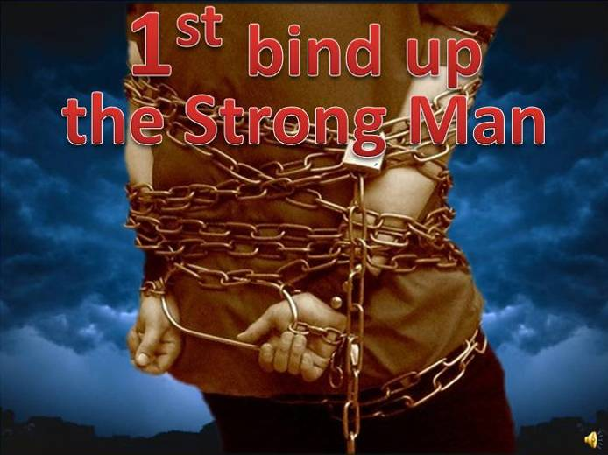
Jesus said we must first bind up the strong man, and then take his goods.
So until the demonic realm is properly dealt with, there won’t be the revival so many are waiting for.

And they will continually interfere with the end-time harvest.

------------------------------ Slide #14 --------------------------------------------
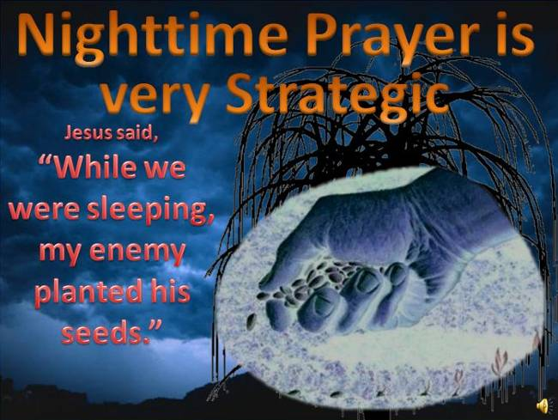
In the parable of the weeds, Jesus said,
“While we were sleeping, my enemy planted his seeds.”

This tells us that the devil does his main work at night, while most Christians are asleep, and nobody is watching or praying.

Therefore, as many Christian's already know, nighttime is the most strategic time to pray, when the fighting is the most intense.

Stopping the enemy when his work is just a seed, is much easier than dealing with a full grown tree.
------------------------------ Slide #15 --------------------------------------------
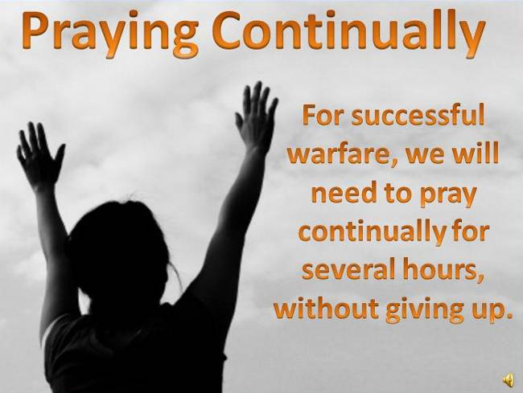
Jesus said that we should always pray and not give up.

For successful warfare, we will need to be ready to pray continually for several hours. You’ll need to press in hard and make a commitment, until you get a break through.

In the book, the church prayed all night long, for several weeks. You should be able to pray for 1, 2 ,3 hours or more.

So DON’T GIVE UP!!!

------------------------------ Slide #16 --------------------------------------------
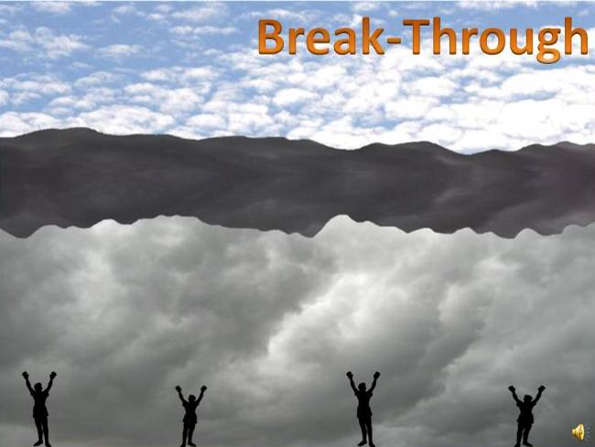
In a vision that was shown to one of my friends. She saw a dark cloud over the earth, filled with evil spirits. And there were Christians underneath it praying.

As the Christians prayed, they would ascend upward toward the dark cloud, pressing into it.

But only those Christian’s that would pray hard & continually, would break through the dark cloud. The rest would eventually fall back down to earth.

The Christians, who would break through, would have victory over their enemy, and victory over their circumstances.

But those who would fall back down would always be dealing with the circumstances, trying just to maintain.

Therefore, a determination to breakthrough in prayer is critical.

------------------------------ Slide #17 --------------------------------------------

In a vision from Mary K Baxter, she was shown a war in the Heavens.

A Demonic spirit in the form of a wizard was high above the earth, doing evil things to the earth.

he would cast evil spells on various people, and other demons joined in. Evil was magnified and sin abounded because of this work. It caused men to steal, to lie, to cheat, and to hurt one another, to speak evil or to succumb to the lusts of the flesh.

But then, in the vision, the people of God began to pray.

They prayed in the name of Jesus and with faith. As they did this, the Word of God came against the evil spirits, forcing them out.
The evil spells were broken, the saints were strengthened and there was great deliverance.

This brought great praise to God, which resulted in even more victories.
There were angelic forces released to destroy the forces of evil.

But when there was disbelief, the evil powers began to overcome.

Jesus said, "My people must believe, and they must agree with each other and with Me," "if all things are to be put under the Father's feet."
------------------------------ Slide #18 --------------------------------------------
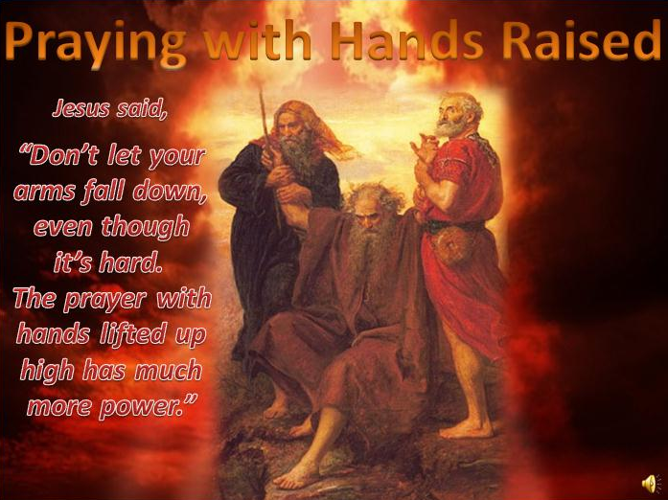
In Exodus 17 it was shown that as long as Moses held up his hands, his army would win the battle.

This is also a technique used is spiritual warfare, in the Baptized by Blazing fire book Jesus said
”Don’t let your arms fall down even though it’s hard. The prayer with hands lifted up high has much more power. ”
So keep your hands up during warfare prayer.

Also, many people have experiences specific types of hand movements while their hands were raised in prayer.

For me, when I’m praying for against evil spirits, my hands would move in one specific pattern.

But then when I pray for more laborers, my hands would move in a different style of pattern.

Also, when I prayed for Justice, a new hand motion started to manifest.

You must be open to move your hands in any fashion that is guided by the Holy Spirit.

------------------------------ Slide #19 --------------------------------------------
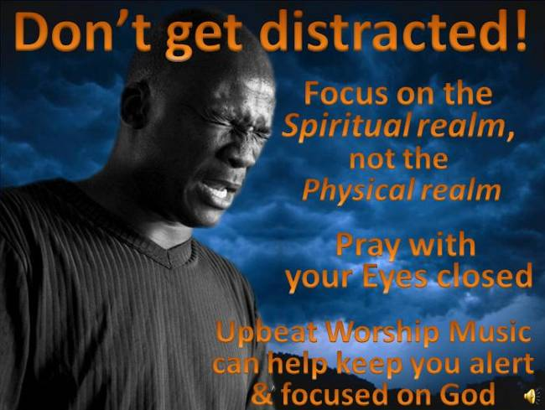
Don't Get Distracted

When praying intensely, it is not good to focus on the physical realm; it only distracts you, and gets your mind off the spiritual reality.

Therefore it is beneficial to close your eyes during prayer, and get into a place where physical things do not distract you, where you can give 100% of your focus to prayer.

Upbeat Worship music can help keep your focus on God, and stay alert for longer periods of time.

------------------------------ Slide #20 --------------------------------------------
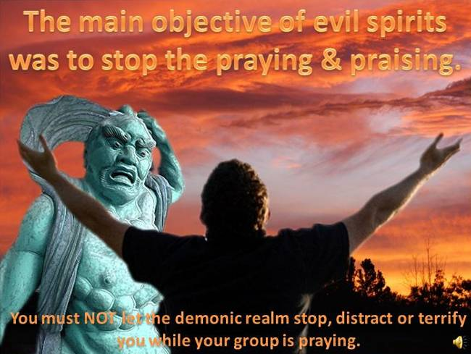
In this revelation, the main objective of the demons was to hinder all aspects of Prayer and Praise.
To stop prayer at all costs, because Prayer and praise would hinder the demonic realm from completing their objectives.
In one example, a high ranked demon came to attack the church. It was a demon with great power to get people to commit suicide. But, it was furious because it was not able to find suicide victims in the city, while this church group was praying and praising.
You must NOT let the demonic realm stop, distract or terrify you while your group is praying.

------------------------------ Slide #21 ----------------------
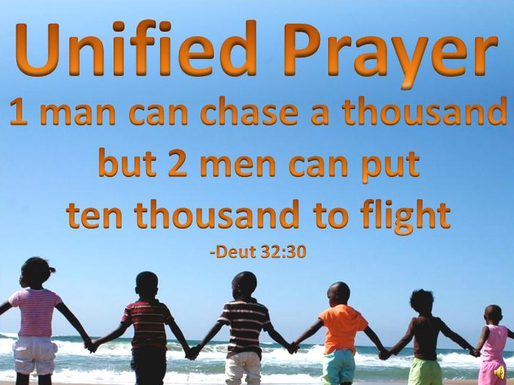
Unified prayer is much more powerful than individual prayer, and many spiritual battles will require a team effort.

In Deuteronomy 32 it shows that 1 man can chase a thousand, but 2 men can put ten thousand to flight.

So to be effective in taking down spiritual principalities and strong holds, you’ll need to surround yourself with dedicated prayer warriors, praying in unity, and praying in agreement.
------------------------------ Slide #22 ----------------------
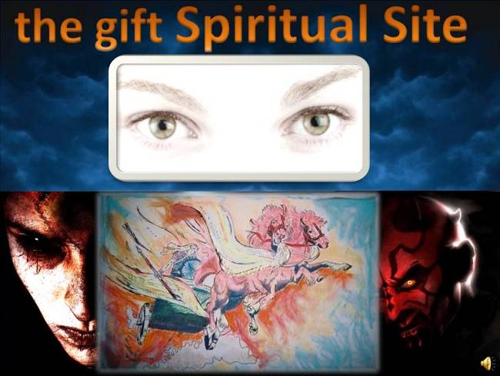
One of the most powerful tools of the demonic spirits is deception and their ability to hide.
In fact, just detecting their presence and revealing their identity is one of the most difficult parts of spiritual warfare.

To counter this, God has granted his people the powerful spiritual gift of Open Site.
This gift is different than the gift of Vision.
Visions are often short visual messages prompted by the Holy Spirit, but Open Site is the ability to continually see into the Spiritual realm.
An example of this was shown to Elisha’s servant in 2nd Kings 6:17, where he was allowed to see the hills full of horses and chariots of fire.
The gift of open site devastates the demon's ability to hide, and allows a Christian to confront these evil spirits head on.

But remember, even though an evil spirit can be seen, many of them can STILL disguise their appearance, pretending to be something that they are not. Those people, who are given the gift of spiritual site, will be under relentless attack, and deception. Discernment & testing of spirits is very critical, these spirits may be able to deceive your eyes, but they cannot deceive the Holy Spirit.

Also, it’s wise to remember that it is God who decides which gifts are given to which people; open site can’t be eared or attained, only granted.
------------------------------ Slide #23 ----------------------
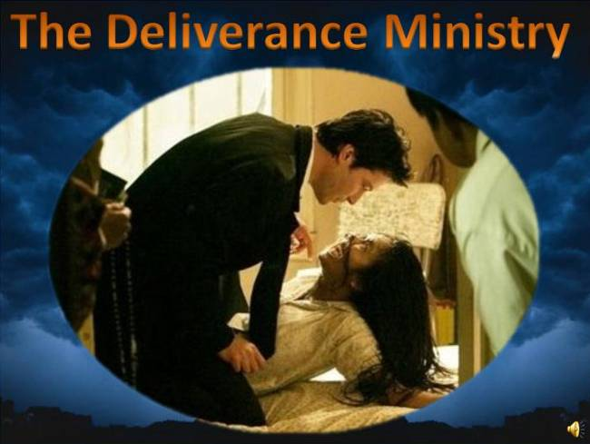
The gift of Spiritual Site greatly enhances the deliverance ministry.
Normally in deliverance, a serious effort needs to be made just to identify which spirits you’re dealing with. And after deliverance is completed, it is difficult to determine if all the evil spirits are out. Spiritual site enable a Christian to see who they are dealing with.

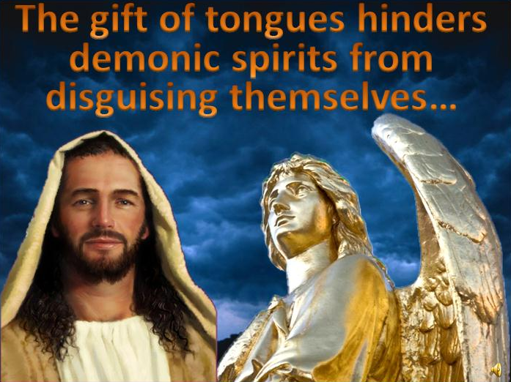
------------------------------ Slide #24 ----------------------
Many demonic spirits posses the ability to disguise their appearance and voice. This calls for the strict testing of all spirits.
The gift of tongues hinders demonic spirits from disguising themselves.
In once example, a Christian was approached by 5 beautiful angels. These angels presented themselves graciously, and even had friendly smiles. The Christian followed the pastor’s advice and continued to pray in tongues. Soon, all the angels turned black, lost their wings, and started to move in bizarre ways. They were exposed! The gift of tongues hinders them from disguising their appearance.
In another example, one of the members of the Church, a strong and dedicated intercessor, was eventually led away from the church by a false christ. All Spirits must be tested, do not get become lax on this, and never let your guard down. It doesn’t insult Jesus if a Christian obeys the bible, and tests whether he really is Jesus.
------------------------------ Slide #25 ----------------------
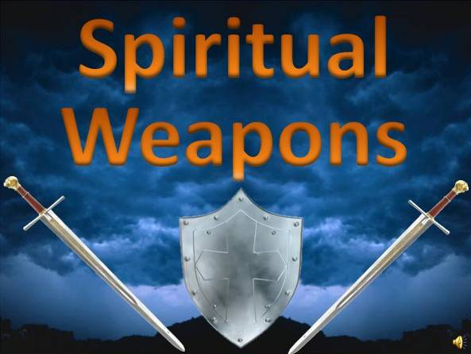
What are the new weapons that have been revealed to the Church?
From scripture we understand the need for rebuking and driving out evil spirits, but driving out evil spirits, may leave them the opportunity to return.
Now it has been clearly revealed that the spiritual bodies of demons can be wounded, tormented and even destroyed.

------------------------------ Slide #26 ----------------------
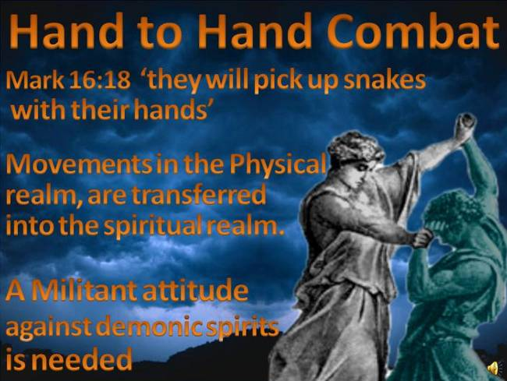
It has also been revealed that Christian can engage demonic, spirits in Hand to Hand combat.

This was spoken of by Jesus in Mark 16:18, when He said, “They shall pick up snakes with their hands"

When you're engaged in spiritual warfare, Movements in the Physical realm are transferred into the Spiritual realm.

In the book Baptized by blazing fire, the members of the Lord’s Church would often strike evil spirits with their fists, gouge out their eyes, crush them, and throw them against the wall.
Violence in not normally a Christian virtue, but a militant attitude against demonic spirits is needed.
------------------------------ Slide #27 ----------------------
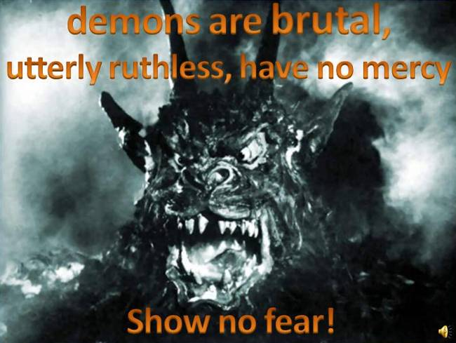
demons are brutal, utterly ruthless and they have no mercy.
They only come to kill, steal and destroy.

Don’t negotiate with them; the only language they understand is fear, threatening, violence and torment.
So you must violently oppose them.

But be ready, demons are not wimps, you’re going to get hit hard sooner or later, that’s just to be expected, so take your wounds like a man.

You must have the mentality that they harder they fight, the more fierce you become.
If you show any fear, it just encourages them attack harder.

------------------------------ Slide #28 ----------------------
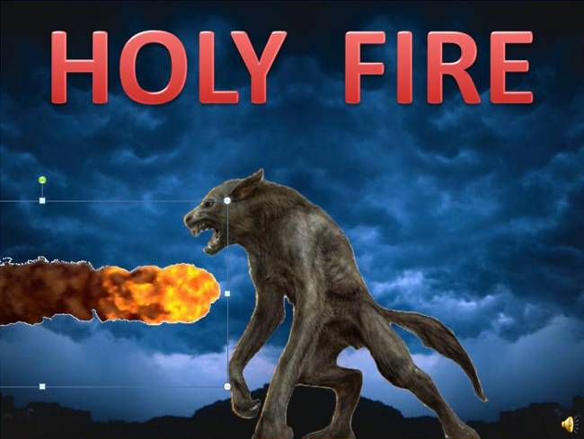
One of the strongest weapons against demons is Holy Fire.
This was revealed to the Prophet Elijah, in 2nd Kings 1:12, where he called down fire from heaven.
Christians also have this power.

In many examples, it was shown that Crying out “HOLY FIRE” would send blazing fire out against demonic spirits, which would wound or destroy them.
------------------------------ Slide #29 ----------------------
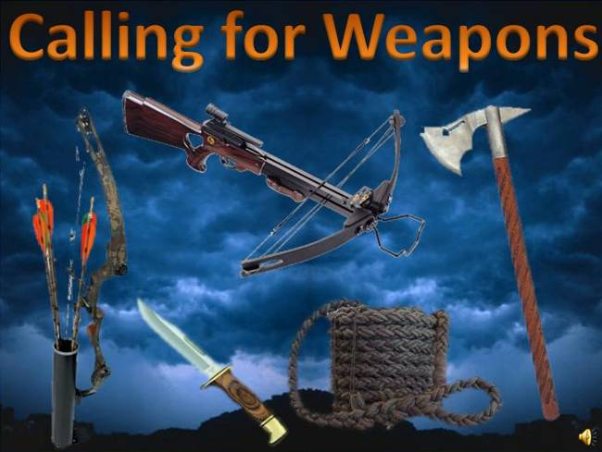
It has been shown that during spiritual warfare, you can call down weapons from the Kingdom of God.
Many different weapons for any specific circumstance can be brought to you, by prayer.

------------------------------ Slide #30 ----------------------
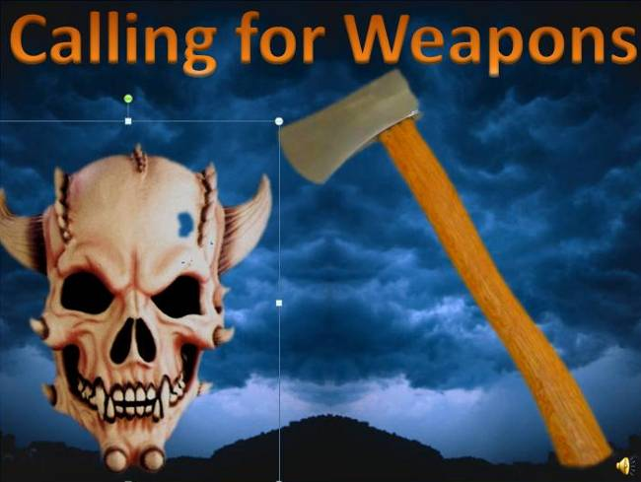
In one example, a Christian was attacked by a skull demon.
The Christian simply prayed for an axe, and one just appeared by their side. With the axe, the Christian smashed the demons head, destroying it.
So there are many weapons available in Spiritual Warfare, depending on your situation.

So don’t hesitate to ask.
------------------------------ Slide #31 ----------------------
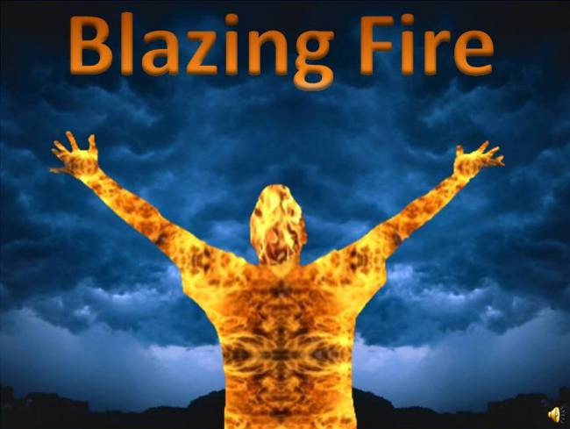
One of the most powerful weapons used in Spiritual Warfare is Blazing Fire.

When this gift is granted to a saint, their entire Spiritual Body is fully engulfed in holy fire, with a blazing intensity.

The fire is so intense, that a mere touch of a demonic spirit will incinerate it to ashes.

This weapon was so powerful, that when the pastor was engulfed in blazing fire, the congregation would often stop fighting the demonic spirits, and simply just threw them at the pastor, incinerating them.

------------------------------ Slide #32 ----------------------
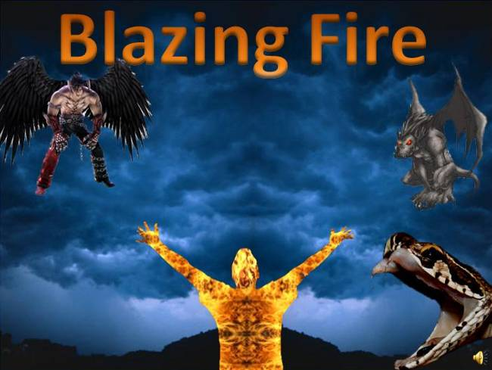
Many times, evil spirits would come to attack a saint engulfed in blazing fire. But it was useless, there was just no way to attack or penetrate. Each one would perish upon contact.

Eventually they learned not to attack these saints head on.
------------------------------ Slide #33 ----------------------
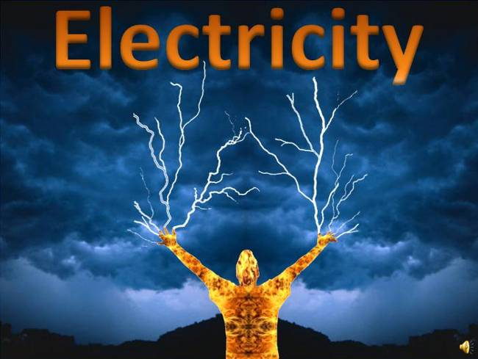
Another powerful weapon that has been released to the Church is electricity, also known as electric power of the Holy Spirit.

Those who have been granted this power are able to handle stronger and stronger demonic spirits.
It is a weapon that neutralizes and destroys the enemy.

But, God warned the congregation many times that if they became arrogant and corrupt; this would be taken away and given to others.

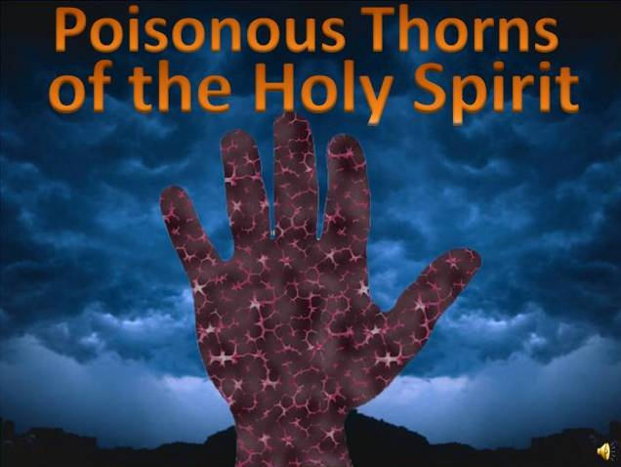
------------------------------ Slide #34 ----------------------
Another powerful spiritual gift that God has granted his people is “Poisonous Thorns of the Holy Spirit”.
When a saint has this gift, and calls upon it, the saint’s spiritual body would be covered with sharp poisonous thrones.

This gift greatly hindered demons from entering a person. The poison is very strong. And upon contact, a demonic spirit would be destroyed, even turned to ashes.
Once a saint had this power, evil spirits would avoid them. However, some of the stronger spirits did attempt to penetrate the poisonous thrones.
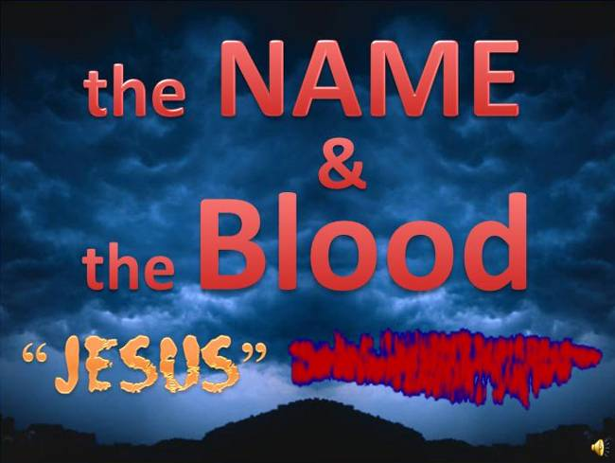
------------------------------ Slide #35 ----------------------
We must not neglect the 2 main weapons of a Christian.
The Name & the Blood

Though the other weapons can be fascinating, these weapons were most often used.
Every Christian needs to understand and use the Name of Jesus and the Blood of Jesus for their protection.

------------------------------ Slide #36 ----------------------
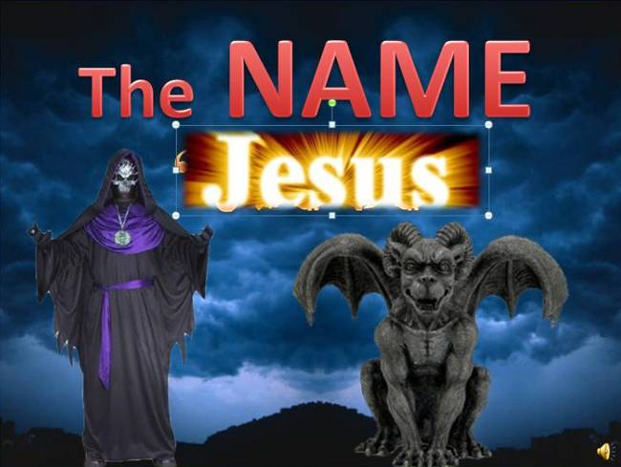
When the Name of Jesus was used, most demons won't fight, they'll just flee away.

Like light driving out darkness, the Name drives them away.

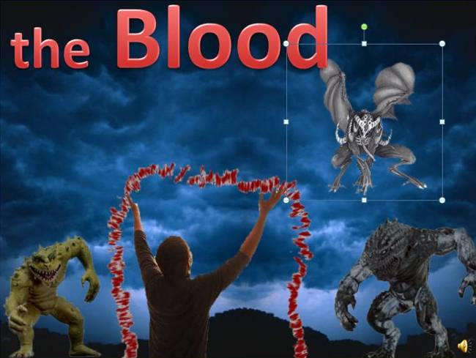
------------------------------ Slide #37 ----------------------
The Blood of Jesus is like a barrier, that evil spirits cannot break through.
It protects a Christian from many of the attacks of the enemy.

But the blood can also be used as an offensive weapon.

------------------------------ Slide #38 ----------------------
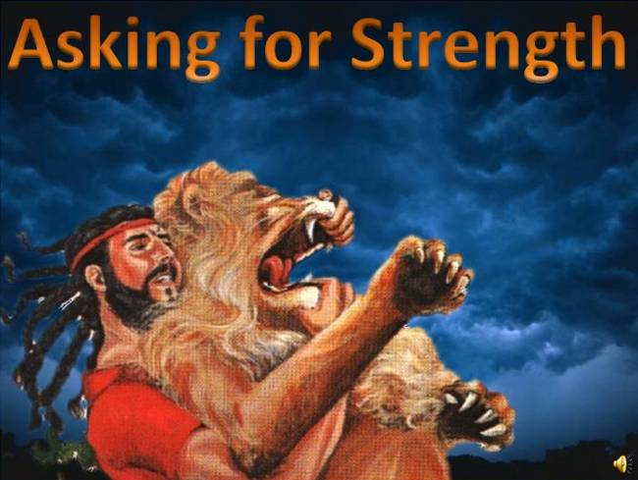
While engaged in hand to hand combat against demonic spirits, remember you can ask Jesus for Great Strength.

In one recorded battle, a saint was totally overpowered by an evil spirit in the form of a large anaconda; he was being suffocated and crushed to death. But after praying for strength, he was then easily able to defeat it.

Like Sampson, God's strength puts the enemy at a great disadvantage.
------------------------------ Slide #39 ----------------------

One of the things that scared the demons the most was to have their identities revealed.
Exposing who they are and what their function is.
In the Baptized by Blazing Fire book, many demonic identities were revealed.

------------------------------ Slide #40 ----------------------

Some evil spirits appeared to the congregation as Beautiful women.
Speaking with an eloquent & soft voice, and walking like a model.
They looked more beautiful than any woman on Earth.
But using the gift of tongues hindered their ability to hide, revealing hideous looking demonic creatures underneath.

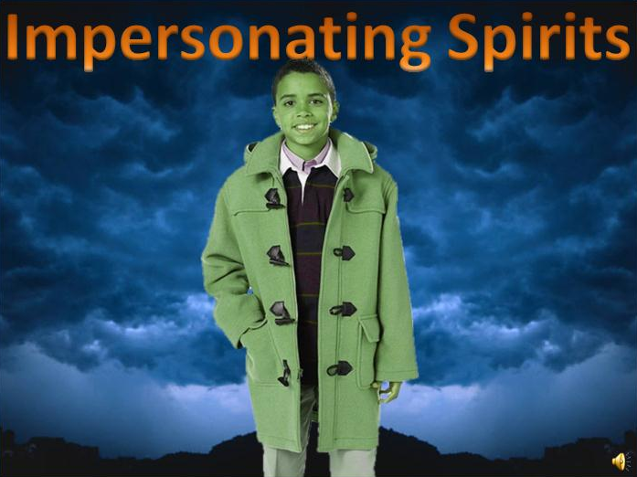
------------------------------ Slide #41 ----------------------
Certain evil spirits have the ability to impersonate people we are familiar with.
This calls for discernment and caution.
Remember, no disguise can fool the Holy Spirit, so one must always be sensitive to His promptings.
------------------------------ Slide #42 ----------------------

In the book, many evil spirits would often appear as young little girls.
In this innocent form, they would hope a saint would drop his guard, and then lead them astray. Yet these spirits are some of the most deadly ones.

------------------------------ Slide #43 ----------------------

This series of books also uncovers the devil’s special forces; powerful group of evil spirits that are very hard to see, yet they themselves are full of eyes.
These spirits would mostly stay back, away from the fighting, and wait for a perfect opportunity to attack.

They are formless, and have great ability to hide, & shift forms.

Once inside a person, they can cause enormous pain, and are very difficult to remove.
------------------------------ Slide #44 ----------------------
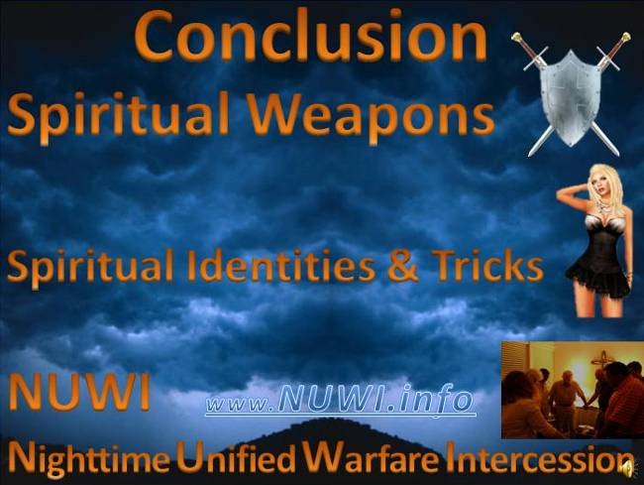
In Conclusion, this was a brief summary of some the tactics used in Spiritual Warfare.

We learned about many powerful spiritual weapons, that saints can use against the kingdom of satan.

We learned about the different Identities of evil spirits, that satan sends against us. Along with his tricks, and techniques he uses.

We also learned about a power style of Spiritual Warfare called NUWI,
Nighttime Unified Warfare Intercession.
As more prayer groups’ start engaging in this style of warfare, the remaining strong holds of satan kingdom will start to fall.

------------------------------ Slide #45 ----------------------
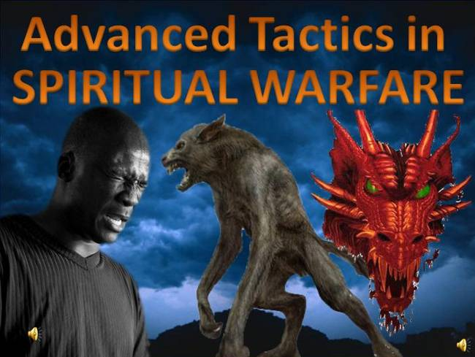
There are many other types of evil spirits not mentioned here.
And there are many other styles of Spiritual Warfare that Christians can use.

We hope this video was informative and Motivating.

Now get out there and FIGHT !!!!

